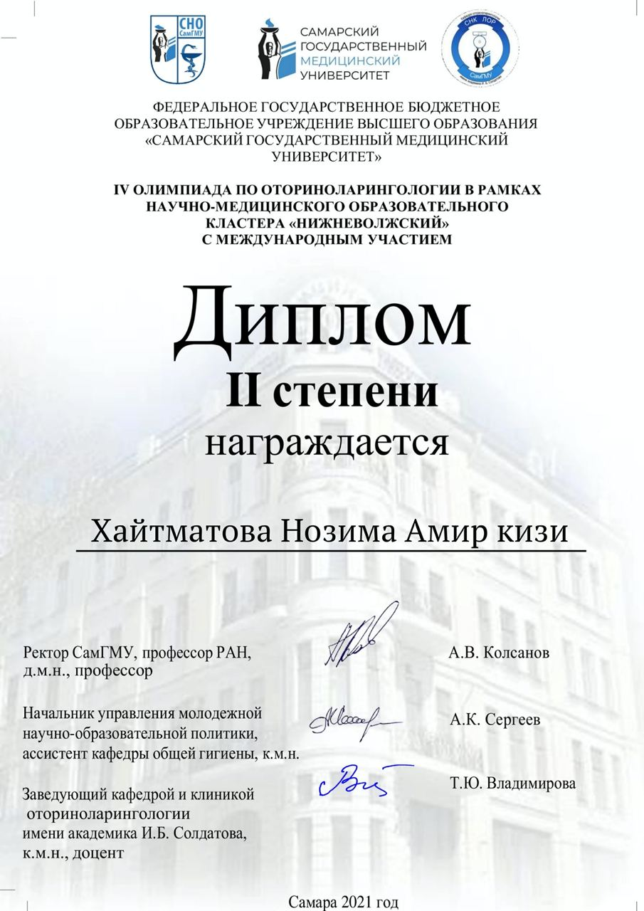

[Logos of the Samara State Medical University]

Federal State Educational Institution of Higher Education

"Samara State Medical University"

IV Olympiad in otorhinolaryngology within the Nizhnevolzhsky cluster with international participation

II DEGREE DIPLOMA

is awarded to

Khaytmatova Nozima Amir qizi

Rector of Samarа State Medical University,

RAS Professor, Doctor of

Medical Sciences, Professor /signed/ A.V. Kolsanov

Head of the Department

of Youth Scientific and Educational Policy,

Assistant of the Department of General Hygiene,

|  |
| --- |
| Candidate of Medical Sciences. /signed/ A.K. Sergeev  Head of the Department and Clinic  of Otorhinolaryngology named  after Academician I.B. Soldatov,  Candidate of Medical Sciences, Docent /signed/ T.Yu. Vladimirova  Samara 2021 |
|  |